Git vs SVN vs CVS

|  |  |  |  |
| --- | --- | --- | --- |
|  | Pros | Cons | Features |
| Git | * Super-fast and efficient performance. * Cross-platform * Code changes can be very easily and clearly tracked. * Easily maintainable and robust. * Offers an amazing command line utility known as git bash. * Also offers GIT GUI where you can very quickly re-scan, state change, sign off, commit & push the code quickly with just a few clicks. | * Complex and bigger history log become difficult to understand. * Does not support keyword expansion and timestamp preservation. | * Provides strong support for non-linear development. * Distributed repository model. * Compatible with existing systems and protocols like HTTP, FTP, ssh. * Capable of efficiently handling small to large sized projects. * Cryptographic authentication of history. * Pluggable merge strategies. * Toolkit-based design. * Periodic explicit object packing. * Garbage accumulates until collected. |
| SVN | * Has a benefit of good GUI tools like TortoiseSVN. * Supports empty directories. * Have better windows support as compared to Git. * Easy to set up and administer. * Integrates well with Windows, leading IDE and Agile tools. | * Does not store the modification time of files. * Does not deal well with filename normalization. * Does not support signed revisions. | * Client-server repository model. However, SVK permits SVN to have distributed branches. * Directories are versioned. * Copying, deleting, moving and renaming operations are also versioned. * Supports atomic commits. * Versioned symbolic links. * Free-form versioned metadata. * Space efficient binary diff storage. * Branching is not dependent upon the file size and this is a cheap operation. * Other features – merge tracking, full MIME support, path-based authorization, file locking, standalone server operation. |
| CVS | * Excellent cross-platform support. * Robust and fully-featured command-line client permits powerful scripting * Helpful support from vast CVS community * allows good web browsing of the source code repository * It’s a very old, well known & understood tool. * Suits the collaborative nature of the open-source world splendidly. | * No integrity checking for source code repository. * Does not support atomic check-outs and commits. * Poor support for distributed source control. * Does not support signed revisions and merge tracking. | * Client-server repository model. * Multiple developers might work on the same project parallelly. * CVS client will keep the working copy of the file up-to-date and requires manual intervention only when an edit conflict occurs * Keeps a historical snapshot of the project. * Anonymous read access. * ‘Update’ command to keep local copies up to date. * Can uphold different branches of a project. * Excludes symbolic links to avoid a security risk. * Uses delta compression technique for efficient storage. |

Src: <https://www.softwaretestinghelp.com/version-control-software/#1_Git>

Git vs CVS: <https://stackoverflow.com/questions/802573/difference-between-git-and-cvs#:~:text=The%20main%20difference%20is%20that,Setting%20up%20repository>.

Git vs SVN: <https://www.perforce.com/blog/vcs/git-vs-svn-what-difference#:~:text=Git%20software%20is%20installed%20on,a%20client%20and%20a%20server.&text=SVN%20has%20a%20separate%20server,changes%20back%20to%20the%20server>.

Možne git rešitve v oblaku

# Bitbucket

<https://www.atlassian.com/software/bitbucket/pricing>

<https://bitbucket.org/product/features>

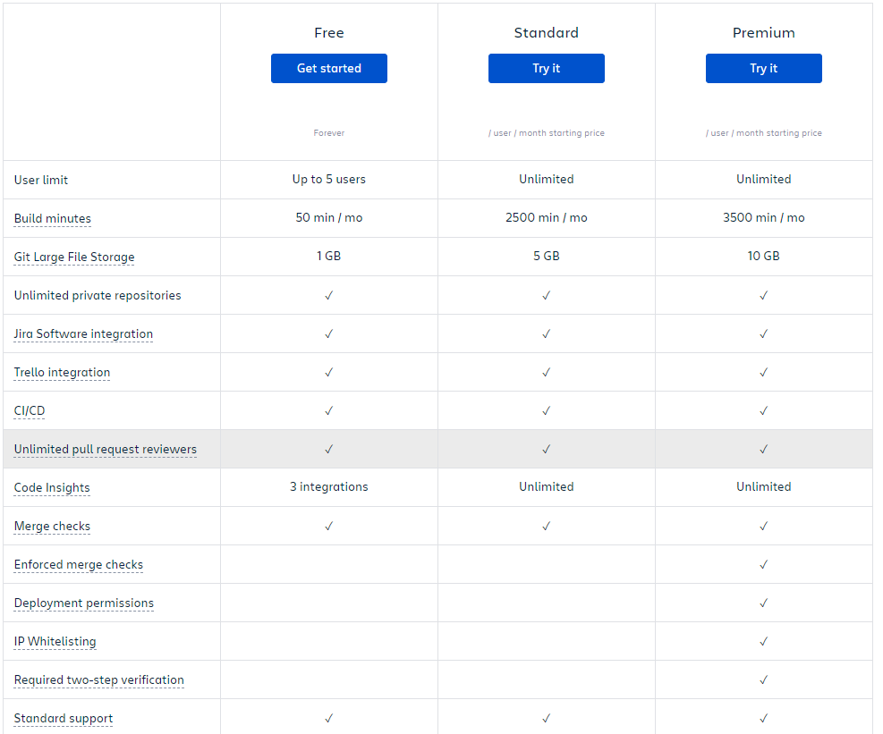

Zastonj do 5 uporabnikov.

Drugače 5€/mesec/uporabnika.

Fokus na integracijo z drugimi attlasian rešitvami (Jira, Trello).

# GitHub

<https://github.com/pricing>

<https://github.com/organizations/plan>

Klasika, od Microsofta.

2GB zastonj prostora na privaten repo. Do 5 kolaboratorjev na projektu na brezplačnem planu.

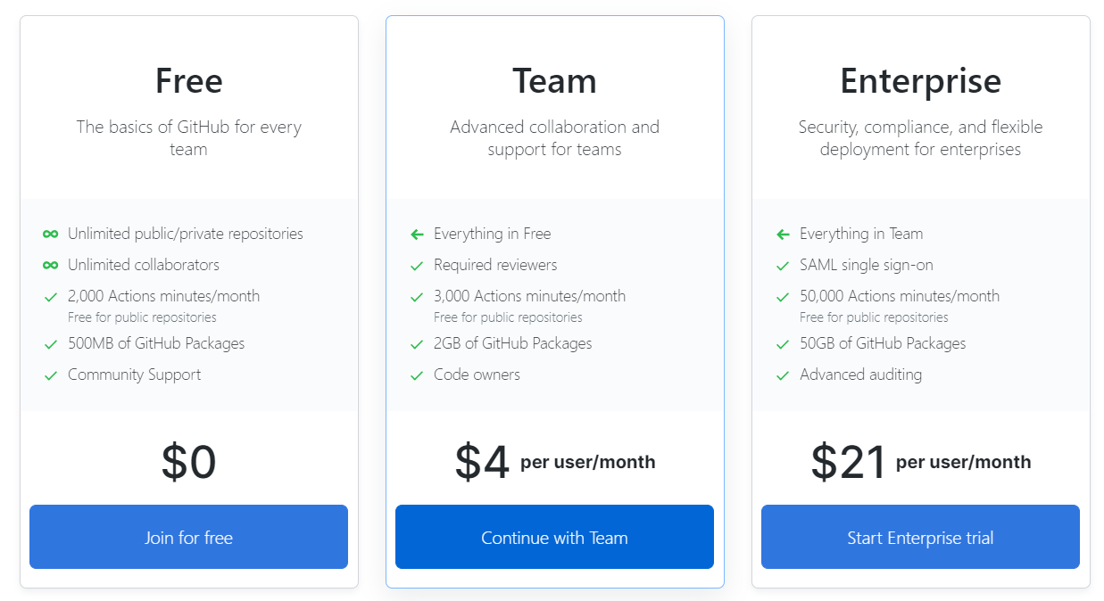

# GitLab



# Primerjava brezplačnih storitev GitLab, GitHub in BitBucket

## Na splošno

<https://stackshare.io/stackups/bitbucket-vs-github-vs-gitlab#:~:text=GitHub%20vs%20Bitbucket%20vs%20GitLab,control%20tools%20offering%20repository%20management.&text=GitHub%20offers%20free%20public%20repositories,Edition%20which%20is%20entirely%20free>.

## Na privatnih repozitorijih

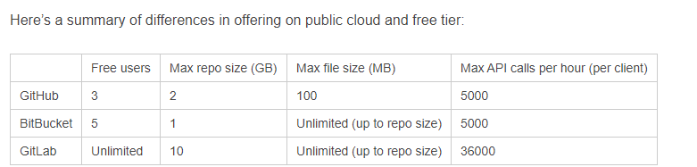

Src: [https://www.almtoolbox.com/blog/github-follows-gitlab-and-bitbucket-now-offers-private-repositories-for-free/#](https://www.almtoolbox.com/blog/github-follows-gitlab-and-bitbucket-now-offers-private-repositories-for-free/)

Na splošno je GitLab

Ostale storitve

# AWS CodeCommit

<https://aws.amazon.com/codecommit/pricing/>

Hramba in kriptiranje.